THE FÍGARO AWARDS 2021 BEAT THEIR RECORD IN PARTICIPATION AND COLLECTIONS!

The most relevant event of the Spanish hairdressing sector has grown this year thanks to the presentation of 187 collections from 29 provinces and 15 autonomous communities, including Andorra, and 9 countries for the international category, that was inaugurated for this edition. By categories, the one with the most participation is Female Commercial Collection, with 54 proposals, followed by Male Commercial Collection with 41, Avant-garde with 35, and 27 in international category.

The 12th edition of the Fígaro Awards has broken its own record with 187 collections that will compete on October 25 to gain recognition from the professional sector of Spanish creative hairdressing. Community Valencian, with 39 collections in total, followed by Catalonia with 23 proposals and Andalusia with 19. Overall, the participating collections come from 29 provinces and 15 autonomous communities, in addition to Andorra.
It is worth highlighting the international participation in its first edition with 15 international firms.
By categories, the one with the most participation is Female Commercial Collection, with 54 proposals, followed by Male Commercial Collection, with 41, and Avant-garde with 35.
In the international category, there will be 27 proposals that will compete to become the International Collection winner.
1/3

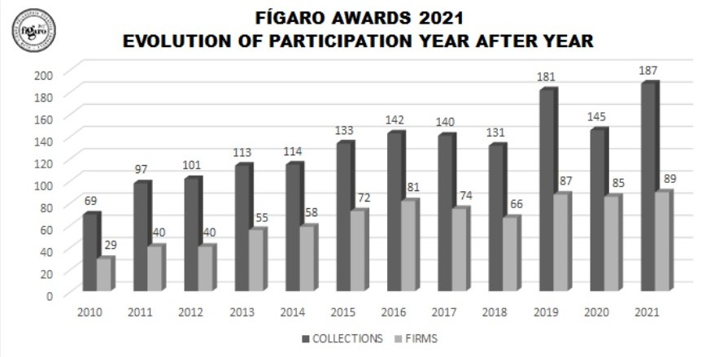
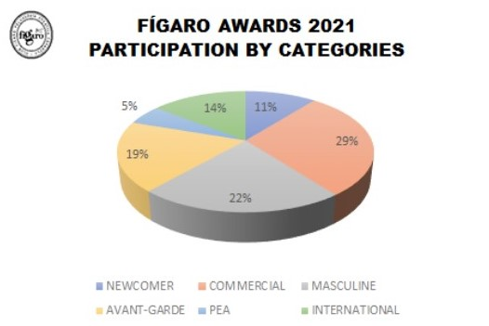

2/3

Once again, the response from the sector has been clear: Spanish creative hairdressing is experiencing a moment of splendour and is more consolidated than ever, turning our country into the cosmopolitan scenario to publicize talent and project the artistic careers of the professionals. Therefore, the resounding support of hairdressers for the Figaro Awards make them undisputed benchmarks in Spain.
The success of Spanish hairdressing and the Fígaro Awards constitutes an attractive claim for international professionals. This is demonstrated by the fact that the international category opens in this edition and 15 firms from outside our country are already participating. Our creative hairdressers are a benchmark for the rest of the world and the Fígaro Awards are the ideal showcase to show their creative talent. An unbeatable opportunity to project Spanish hairdressing beyond our borders.
The Board of Directors and its entire team, together with its main sponsor, Revlon Professional, want to thank all partners and participants for their tenacity, passion, dedication, courage and determination to advance the sector with their daily effort.

3/3

